Acids/Bases and Indicators

Lots of fun chemistry experiments can be done right at home. I’ve used some of the procedures and information provided by Science Buddies and made some changes to make it a family activity that you will all enjoy. If you have fun doing this, try some others from their site. We are going to explore what acids and bases are as well as make an at home indicator allowing us to test the pH of different household items. Ready for some nerdy fun?

Introduction
A solution is a mixture of a soluble chemical dissolved in water. Think about the difference between saltwater and tap water. The salt in the saltwater has dissolved and the solution looks clear, but the salt is still there and will taste salty if you taste it. Because solutions are made with water, which is made of hydrogen and oxygen, the hydrogen in the water can make a solution into an acid or a base.
You might think about an acid as something that an evil villain uses to trap a superhero, but some very common household solutions are acids. Acids are solutions that will donate hydrogen ions in a solution, and usually taste sour. Some common acids are citrus fruit juices and household vinegar. Bases are solutions that accept hydrogen ions in solution, and usually feel slippery. Bases have many practical uses. "Antacids" like TUMS or Rolaids are used to reduce the acidity in your stomach. Other bases make useful household cleaning products.
How do you tell if something is an acid or a base? You use a chemical called an indicator, which changes in color depending on whether a solution is acidic or basic. (Specifically, an indicator works by responding to the levels of hydrogen ions in a solution.) There are many different types of indicators, some are liquids and some are concentrated on little strips of "litmus" paper. Indicators can be extracted from many different sources, including the pigment of many plants.
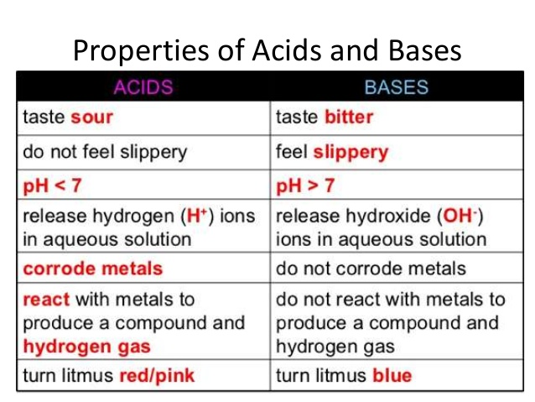
Here is a video explaining Acids and Bases… https://youtu.be/mnbS56HQbaU
What is an indicator???? As we stated earlier, an indicator is a substance that changes colour when it is place in an acidic or basic solution (a mixture of a substance in water like lemon juice of Pepto Bismol). What do we have around home that can be used as an indicator?
Red cabbage contains an indicator pigment molecule called flavin, which is one type of molecule called an anthocyanin. This water-soluble pigment is also found in apple skin, red onion skin, plums, poppies, blueberries, cornflowers, and grapes. Very acidic solutions will turn anthocyanin a red color. Neutral solutions result in a purplish color. Basic solutions make a greenish-yellow or yellow color.

Materials and Equipment
- A small red cabbage (1/4 of a head or about two cups chopped)
- Boiling pot of water
- Blender
- Strainer and coffee filter
- Small white Dixie cups (one for each household item you want to test the pH of) Clear glasses on a white sheet of paper will do
- Medicine dropper, eye dropper, straw with your finger on top..
- Large bowls or pots (2)
- Lab notebook
- A series of household items to test the pH of:
  - Fruit juice: lemon, lime, orange, apple
  - Soda pop (dark sodas might be tricky to see)
  - Vinegar
  - Baking soda solution
  - Glass cleaner
  - Laundry detergent
  - Alka-seltzer, antacid
  - Ammonia
  - Bleach or shower cleaner/ toilet bowl cleaner
  - Anything you want!

Experimental Procedure
- Chop a small red cabbage and place the pieces into a large bowl or pot.
Pour boiling water into the bowl to just cover the cabbage. Use caution when handling the boiling water.
- Leave the cabbage mixture steeping, stirring occasionally, until the liquid is room temperature. This may take at least half an hour. The liquid should be reddish purple in color. Pour the mixture in a blender and blend for 30 seconds.
- Place a small strainer over a second large bowl or pot and line it with a coffee filter. Pour the mixture through the strainer to remove the cabbage pulp. Press down on the pulp in the strainer, such as by using a large spoon, to squeeze more liquid out of the pulp.
- In the bowl, you should now have a clear liquid that will either be purple in color (It should look darker after the pulp is removed.) This will be your indicator solution.
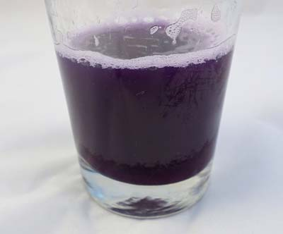
Figure 6. This shows what the indicator solution can look like in a clear glass.
- The color of the liquid will change depending upon the pH. Use Table 1, below, to figure out the pH of the liquid by observing the color.
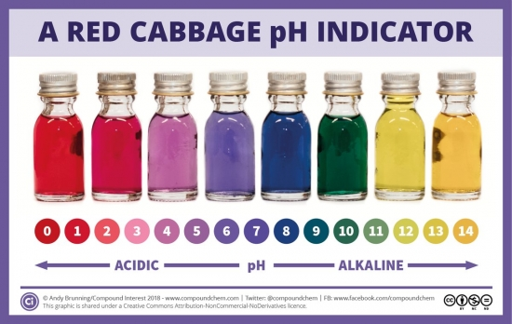

Table 1. This table shows what the pH of the liquid should be based on its color.
- Set aside your indicator solution. You will use it as your "stock" solution for your experiments.
- Next you will test various household solutions with your indicator. Use a separate Dixie cup or glass for each solution you want to test because you do not want to mix chemicals that do not go well together or contaminate your results.
- Fill about ¼ to ½ of the Dixie cup with your cabbage indicator solution depending on how much indicator solution you made.
- Add drops of a liquid you want to test until you see the solution change in color. Gently swirl the cup as you add the drops, being careful not to spill the solution.
- Record the pH and a description of each solution in a data table in your lab notebook like Table 2 below.
- Analyze your results. How does the pH of the different household items you tested compare to each other? Are you surprised by any of your results?
Substance | Color of indicator | pH according to the colour | Is this what you expected?
Conclusion; That was fun!!!! Science is cool and my teacher rocks!!! Test other household items for pH or different flavin containing fruits and vegetables to make your own indicators!

